## horizontal line

Convolution Operation (part2)

05.04.2025

# History of CNN

CNN would be inspired by our own Visual cortex .

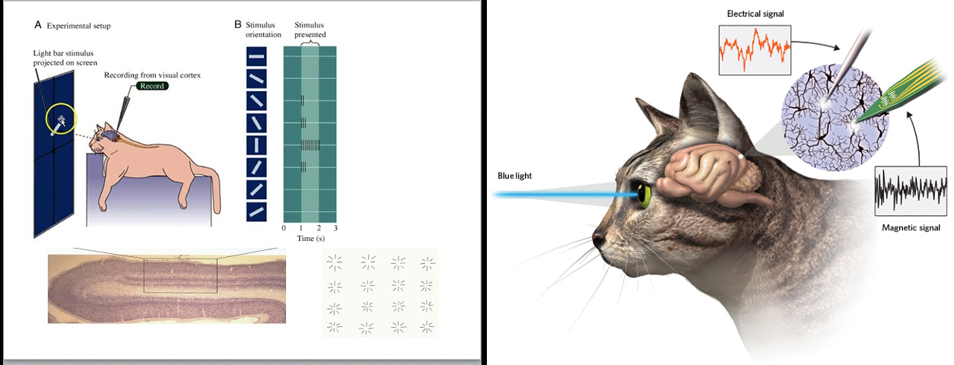

The famous cat experiment shows :

1. The one particular cell in the visual cortex of the cat gives full signal only for a particular edge (either vertical / horizontal).
2. Not any cell responds for all edges; this implies that each cell captures a single primitive feature .

# Conclusion

There are two types of cell in the visual cortex .

1. Simple cell - orientation cell (feature detection) , smaller receptive field (only one). Preferred stimuli.
2. Complex cell - bigger receptive field . Form complex patterns from simpler ones.

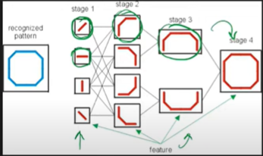

# Convolution Operation

CNN is composed of 3 layers .

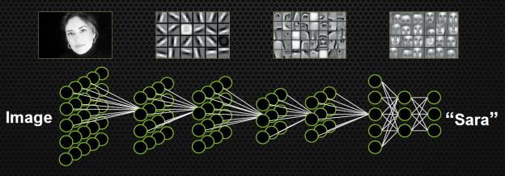

## Basics of Image

There are two types of images.

1. Grey Scale Image 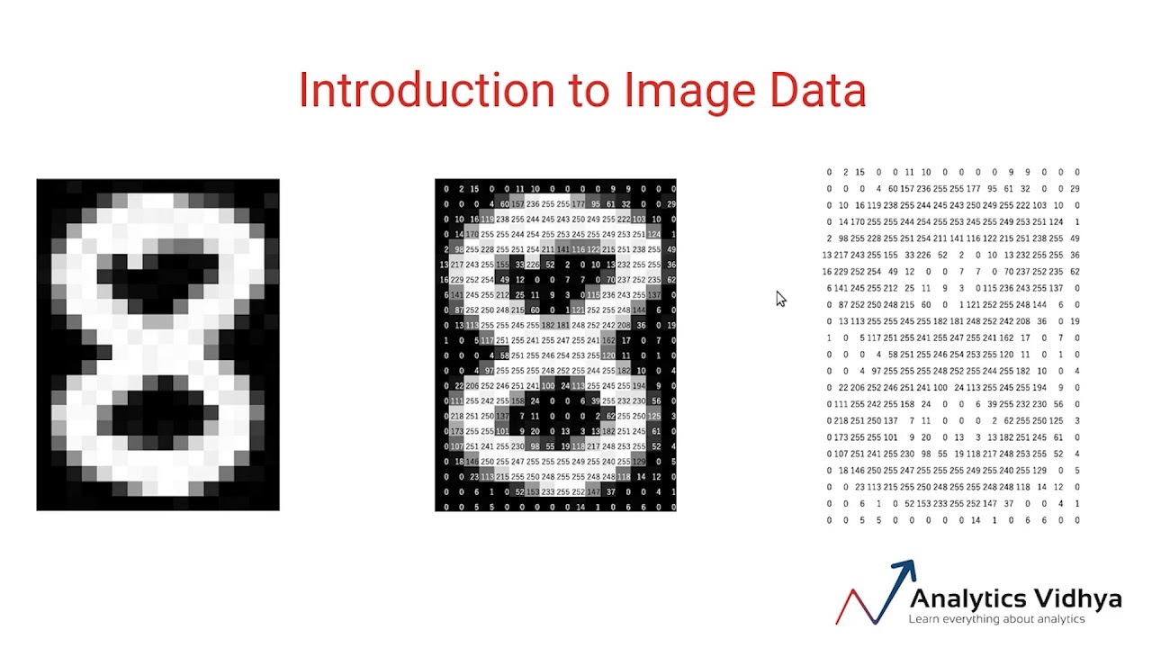

Pixels are between 0-255 . 0 for black and 1 for white.

1. RGB colored Images

There are 3 channels in it while only one in grayscale.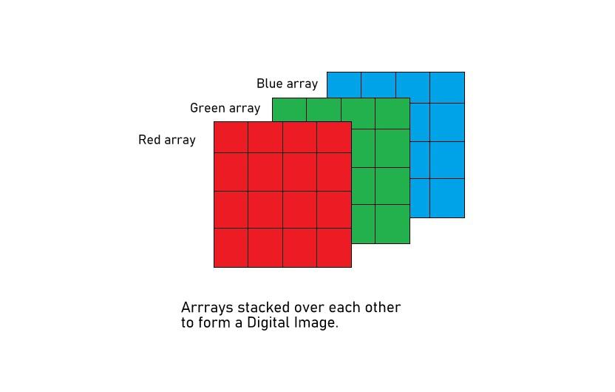

# Edge Detection

Change in intensity is basically an edge . For different edge detection there are different filters like H , V etc…

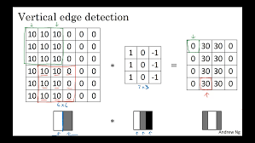

For an array of 6X6 ,a filter of 3X3 convolves , a feature map of 4X4 will be returned giving vertical edges.

In general mXm * nXn = (m-n+1)X(m-n+1)

In RGB ,

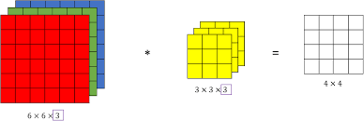

For multiple filters ,

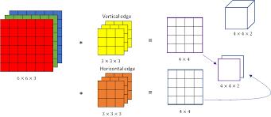

They will act as input for next layers.